Fluorescent Secondary School

Tokha, Kathmandu

A project report of Chemistry

Bio- Inorganic Chemistry

Submitted by:

Name: Niranjan Kattel

Stream: Science

Grade: XI

Section: “A”

Academic Year: 2023

Submitted To: Aarati Kafle

Department of Chemistry

Teachers Signature:

Date:

ACKNOWLEDGEMENT

I would like to express my gratitude to everyone who has contributed to the successful completion of this chemistry project. Firstly, I would like to thank my teacher, Aarati Kafle, for guiding and supporting me throughout the project. Your valuable suggestions and insights have been instrumental in shaping this project.

Niranjan Kattel

Fluorescent Secondary School

Introduction to Bio-Inorganic Chemistry

Table of contents

|  |  |  |
| --- | --- | --- |
| 1. | Introduction……………………………… | 3 |

|  |  |  |
| --- | --- | --- |
| 2. | Macronutrients and Micronutrients…. | 3 |

|  |  |  |
| --- | --- | --- |
| 3. | Importance of Metal ions………………. | 7 |

|  |  |  |  |
| --- | --- | --- | --- |
| 4. | Ion Pumps………………………………... | | 10 |
| i. | Sodium-Potassium pump |  |
| ii. | Sodium-glucose pump |  |

|  |  |  |
| --- | --- | --- |
| 5. | Metal Toxicity…………………………… | 13 |

Introduction

Bio-inorganic Chemistry is a branch of chemistry which deals with the study of inorganic substances in the living systems in terms of the various aspects like transport, structural support, defense, therapeutic action, enzymatic action, toxicity, nutrition, etc.

Macronutrients

The nutrients which are required in large amount for that normal growth and survival of organisms are called macronutrients. E.g.: Carbohydrate, fats, water, fiber and protein

Functions of major Macronutrients:

1. Carbohydrates:

Provides energy, stores energy, build macromolecules and spares the use of protein.

Sources: oat, barley, wheat, lentil, potato, beans, fruit, etc.

1. Protein:

Transports oxygen, antibodies, enzymes, providing structures, movement in muscles, cell signaling, etc. Sources: Dairy, meat, fish, beans, egg, etc.

1. Fats:

Structural component of cell membrane, signaling, storing energy, fatty acid metabolism, transport chemical substance, etc. Sources: Vegetable oil, meats, Dairy products, etc.

1. Fiber:

Improvement of blood sugar levels and cholesterol, body weight control, eliminates toxins through digestive colon, etc. Sources: Oat, barely, wheat, grains, carrots, breads, melons, nuts, etc.

1. Water:

Regulation of temperature and pH, protection of spinal cords and joints, removal of body waste, etc. Sources: Drinking water, fruit juices, beverages, etc.

Micronutrients

The nutrients which are required in small amounts for the growth and survival of organisms are called micronutrients. E.g.: Minerals and vitamins

Functions of Water-soluble Vitamins:

1. Vitamin B1 (thiamine): Conversion of nutrients into energy. The major sources are meat, fish, whole grain, etc.
2. Vitamin B2 (Riboflavin): Fat metabolism. The major sources are meat, egg, milk, etc.
3. Vitamin B3 (niacin): Production of energy from food. The major

sources are meat, salmon, beans, etc.

1. Vitamin B5 (pantothenic acid): fatty acid synthesis. The major sources are Mushroom, tuna, avocado, etc.
2. Vitamin B6 (pyridoxine): Release of sugar from stored carbohydrate. The major sources are Fish, milk, potato, carrot, etc.
3. Vitamin B7 (biotin): Metabolism of glucose and amino acid. The major sources are egg, sweet potato, almonds, etc.
4. Vitamin B9 (foliate): Cell Division. The major sources are Liver, asparagus, etc.
5. Vitamin B12 (cobalamin): RBC formation and brain function. The major sources are meat and fish.
6. Vitamin C (ascorbic acid): Transfer of neuron transmitter and collagen. The major sources are peppers, sprouts, citrus fruits, etc.

Functions of Fat-soluble Vitamins:

1. Vitamin A: Vision and proper function of organs. The major sources are carrot, fish, Dairy, liver, etc.
2. Vitamin D: Immune system and calcium absorption. The major sources are sunlight, milk, fish oil, etc.
3. Vitamin E: Protection of cell damage, Immune system. The major sources are seed of sunflower, almond, wheat grain, etc.
4. Vitamin K: Clotting of blood and Bone development. The major sources are soyabean, pumpkin, leafy green, etc.

Minerals:

Minerals are the essential macronutrients for proper bone growth, maintenance of proper blood pressure, fluid balance, etc. They can be classified as:

1. Macrominerals

(Required in larger amount)

1. Microminerals

(Required in smaller or trace amounts)

|  |  |  |
| --- | --- | --- |
| Macrominerals | | |
| Mineral | Main Function | Main Sources |
| Calcium | Proper structure of bones and teeth | Milk products, broccoli, leafy green |
| Phosphorus | Cell membrane structure and bones | Yogurt, turkey, salmon |
| Magnesium | Regulation of Blood pressure and enzyme reaction | Black beans, Almonds, cashews |
| Sodium | Maintenance of blood pressure and fluid balance | Salt, processed salts |
| Chlorine | Water and salt balance, rid of body toxins | Salts, seaweed, celery |
| Potassium | Nerve transmission and muscle function | Banana, lentils |
| Sulphur | Major elements in some amino acids like cysteine | Garlic, onion, egg |

|  |  |  |
| --- | --- | --- |
| Microminerals | | |
| Mineral | Main Function | Main Sources |
| Iron | Oxygen carrier providing oxygen to muscles | White beans, spinach, gundruk |
| Manganese | Metabolism of carbohydrate, amino acids, cholesterol | Pineapple, peanuts |
| Copper | Formation of connective tissues, nervous system | liver, cashews, crabs |
| Zinc | Immune system and normal growth | oysters, crabs |
| Iodine | Thyroid regulation | seaweeds,  yogurt, cod |
| Fluorine | Development of bones and teeth | Crab, water |
| Selenium | Protection against oxidative damage, thyroid function | Brazil nuts, ham, sardine |

|  |  |  |
| --- | --- | --- |
| Differences Between | | |
| SN. | Macronutrients | Micronutrients |
| 1. | For the normal growth and survival of the organisms, they are required in large quantity. | For the normal growth and survival of the organisms they are required in small quantity. |
| 2. | Protein, carbohydrate, lipids, and water are the examples of macronutrients. | Vitamins minerals and antioxidants are the examples of micronutrients. |
| 3. | They may include both the minerals and non-minerals. | They mainly include minerals. |
| 4. | Their deficiencies cause malfunctions like malnutrition, kwashiorkor, etc. | Their deficiency cause diseases like greater anemia, scurvy, etc. |
| 5. | They have large abundance in almost all the plant products and some animal products. | They are found in a minute quantity in selected plants and animal products. |
| 6. | They’re overdoses may cause problems like hypertension, diabetes, obesity, etc. | They are overdoses may cause damage of liver, bones, nerve centers, etc. |

Importance of Metal ions in Biological System

Some metal ions are required in large and some in trace amounts. The metals have various roles in biological system. Some important Metal ions are outlined below:

1. Sodium (Na): Sodium (Na+) is found in body fluid. It maintains blood volume and blood pressure. It also prevents the chance of collapse of the cells. It is very essential to transmit the nerve impulses. Insufficiency of sodium may cause the problems like headache and coma. Whereas, the excess amount increases the risk of heart failure and kidney disease. In plants sodium helps to promote metabolism in small amount.
2. Potassium (K): Potassium (K+) helps in muscle contractions, heart beat and reflexes. It helps in regulating the fluid balance. Insufficiency of potassium may cause weakness, muscle cramp, mood swing and difficult in breathings. In plants, it helps in photosynthesis. It also helps in production of Adenosine Triphosphate (ATP).
3. Magnesium (Mg): Magnesium helps to build healthy immune system, adjusting proper blood sugar level and supporting the production of protein and energy. It also helps in healthy brain development. Insufficiency of Magnesium leads to high blood pressure, weakness and depression. In plants, it is the major element of chlorophyll and helps in photosynthesis.
4. Iron (Fe): It is the oxygen carrier in many organisms. Hemoglobin (protein containing iron) helps to carry oxygen from lugs to tissues. Whereas, myoglobin stores oxygen. Cytochrome is necessary in plants and animals to perform electron transfer reaction. It helps to convert biochemical energy from nutrients into Adenosine triphosphate (ATP) through cellular respiration. Insufficiency of Iron in body causes anemia
5. Copper (Cu): Highest concentrations of Cu are normally found in the liver, kidney, heart and brain. It is found in all body tissues and plays a versatile role in making red blood cells and maintaining nerve cells and also the immune system. It equally helps the body to absorb iron, and to produce energy. Insufficiency of copper always feels cold, easy bone breakage, easy bruising, fatigue, getting sick frequently, pale skin, poor growth, skin inflammation, skin sores and problems with the muscle movement. The major sources of copper are oysters, crab meat, cashew nuts, sunflower seeds, whole grain bread and pasta, broccoli, potatoes and bananas, etc.
6. Zinc (Zn): Zinc is a trace element that is essential for a healthy immune system. Zinc helps in Regulation of immune system, Activation of T cells (Lymphocytes) which attacks cancerous cells, Reduction of diarrhea. Insufficiency of zinc leads to loss of appetite, anemia, slow healing of wounds, growth depression, diarrhea, hair loss etc.
7. Nickel (Ni): The role of nickel is associated with enzymes that affect the breakdown and use of glucose. It also helps for the production of milk in the mammary glands. It is also involved in the production and action of certain hormones. It is helping in the creation of red blood cells and is necessary in the metabolism of sugars, fats, hormones and cell membranes. Insufficiency of nickel Affects optimal growth, healthy skin and bone structure, leads to kidney and liver diseases and affects the absorption of iron from food and lead to anemia.
8. Cobalt (Co): It is essential in the metabolism of folic acid and fatty acids. It is useful to human being in the form of vitamin B12 (cobalamin). It is used in the production of red blood cells and is important for the proper functioning of the nervous system. The excess of cobalt leads to the disorders like nausea, heart problems, goiter, kidney damage, nerve damage, thickening of blood etc. Insufficiency of cobalt leads to great loss of blood causing amenia.
9. Chromium (Cr): It may also be directly involved in the process of metabolism and may have benefits when taken as a supplement. Chromium supplement may help with weight loss, reduction of body fat and increase of lean muscle. Bodybuilders and other athletes also use chromium to give the strength to the muscle. Use of chromium gives the benefits of lowering of blood pressure. Chromium deficiency is rare. Chromium is absorbed only in 5%.

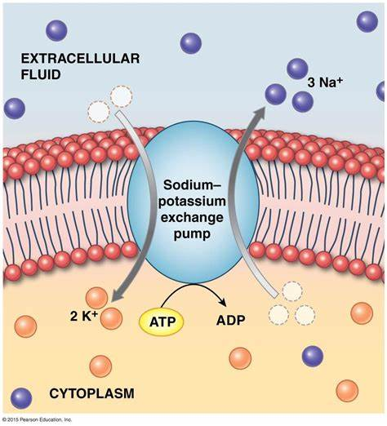Ion Pumps

Active transport is a process where cells move molecules or ions from an area where there are fewer of them to an area where there are more of them. It is observed in human body that some substances or ions present in large concentration in Extra Cellular Fluid (ECF) and small concentration in Intra Cellular Fluid (ICF). Two ion pumps are discussed briefly below:

Sodium-Potassium Pump

Na – K pump involves primary active phenomenon in which Na+ ions have active transport to expulsion from the cell and k+ ions have active transport to enter the cell by the absorption of energy released from the hydrolysis of Adenosine triphosphate (ATP) to Adenosine diphosphate (ADP). The sodium-potassium pump is a well-known example of a cellular ion pump that helps maintain the proper balance of sodium and potassium ions in cells.

The mechanism of Na-K pump is briefly discussed here. First of all, in Na – K pump, the carrier protein channel allows to bind 3Na+ ions and 1 molecule of ATP from ICF. The splitting of ATP provides energy to change the conformation of the channel of carrier protein and 3Na+ enter occupying their sites in the channel. Here one phosphate (P) is also attached with the protein. 3Na+ ions are expelled outside the membrane from their sites and 2K+ ion enter from outside and occupy their respective sites in the channel. Release of phosphate from the carrier protein changes the conformation of the channel to revert to the original from and 2K+ ions release from their sites and enter inside the cell containing ICF.

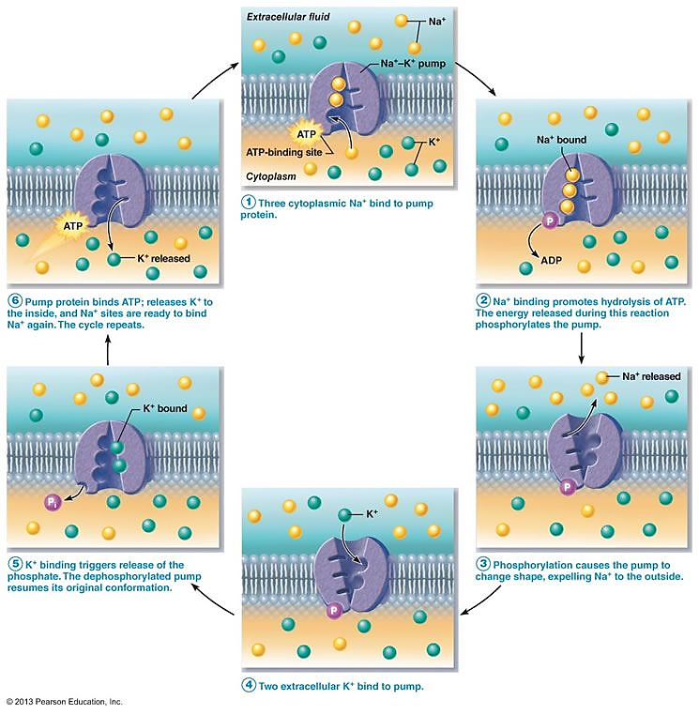Sodium-Glucose Pump

The primary active transport of Na – K pump develops a large concentration gradient of Na+ ion by acquiring its high concentration outside and low concentration inside the cell membrane. This gradient is also known as electrochemical gradient and it is a store house of energy. The diffusion energy of sodium then pulls the other substance such as glucose molecule along Na+ through the cell membrane into the ICF. This phenomenon is secondary active transport that involves in Na – glucose pump.

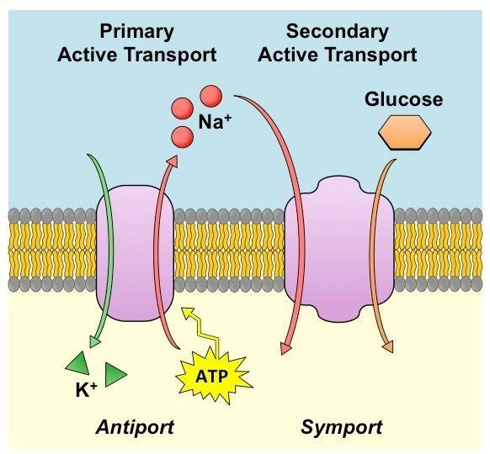The mechanism of secondary active transport is studied in detail in sodium-glucose pump It also known as co-transport of glucose along with sodium ions or sodium glucose link transport (SGLT). Here, the transport carrier protein present being penetrated through the cell membrane and the protein on its external side has two binding sites, one for Na+ ion and one for glucose molecule.

Carrier protein uses the energy of concentration gradient of sodium to drive the transport of glucose molecule. The conformational change in carrier protein do not occur to allow the movement of Na+ inside unless glucose is attached with it. In this pump the carrier protein is also called symport transporter because it transports two different species Na and glucose along same direction.

Importance of Sodium-Glucose pump:

It is important for transporting glucose from extra cellular fluid to cytoplasm of all the cells. It is plays important role for re- absorption and also to excrete excess electrolytes being diluted water from the urine.

Metal Toxicity

Metal toxicity refers to the harmful effects of excessive exposure to certain metals that can accumulate in the body over time. The toxic effect of some metals is listed below:

1. Toxicity due to Mercury: Mercury causes Lack of coordination, Muscle weakness, Hearing and speech difficulties, Vision changes, Trouble walking, Damages of nerves related to hands and face. Mercury is found usually in natural forms like metallic mercury.
2. Toxicity due to Lead: Lead causes Constipation, Sleep difficulties, Anemia, Headache, Fatigue, Irritation and memory loss, Loss of appetite. Lead is usually found in leaded petrol, plumbing pipes, drinking water, pesticides, etc.
3. Toxicity due to Arsenic: Arsenic causes Muscle cramps, Nausea, vomiting and diarrhea, unusual heart rhythm, Red or swollen skin, Spots on the skin like warts. Arsenic is found in ground water, paints, arsenal chemicals, etc.
4. Toxicity due to Cadmium: Cadmium causes Fever, Breathing problems, Muscle pain. Cadmium is found in batteries, paint, electrode components, etc.
5. Toxicity due to Iron: Problems on lungs, stomach and intestines, Heart and blood related problems, Liver and skin related issues, Problems on the nervous system.